**Alabs Iron Mini-WL Wireless Desktop**

**USB Condenser Microphone**

**Owner’s Manual**

**(产品主图正面）**

**Overview**

Your Creative Universe, Ultra-HD Quality Audio, Plug and Play.

Your Creative Universe, Ultra-HD Quality Audio, Plug and Play.

Your Creative Universe, Ultra-HD Quality Audio, Plug and Play.

Your Creative Universe, Ultra-HD Quality Audio, Plug and Play.

Wireless Freedom, plug and play, your creative universe.

Thanks for purchasing the Alabs Iron Mini-WL.

The ideal wireless desktop USB condenser microphone system for recording singing and musical performances in addition to spoken applications such as podcasting, gaming and voice-over, Iron Mini-WL offers a highly versatile HD quality audio with simple setup, provides you wireless freedom and sound like a pro.

The UHF wireless allows Iron Mini-WL to operate 100 feet range to freely move around during recording, podcasting and performances without the inconvenience of USB cable. Built in rechargeable Li-ion battery, the Iron Mini-WL provides more than 8 hours of continuous use on a full charge.

The Iron Mini-WL features a zero-latency stereo headphone monitoring (1/8") jack on the receiver, which allows you to monitor the microphone input and audio playback in realtime. The Mute quiet touch key with LED indicator give you convenient to quickly mute the mic while podcasting or recording.

It is fully compatible with all mainstream recording applications on both Windows and Mac OS based computers, as well as the Apple iPad using Garage Band or any other recording app that accepts an external microphone. Simply plug the receiver of Iron Mini-WL into your PC, Mac, iOS (needs extra adapter) or Andriod and turn on the Iron Mini-WL, you're ready to go. System requirements: Windows 8 or higher, Mac OS 10.7 or higher, Android 9 or higher, iOS 10 or higher.

The Iron Mini has incredible warm, rich and full tone that keeps your audience hooked. It also has greater noise suppression compared to traditional cardioid mics to ensure total vocal clarity. Also provided is a flexible, adjustable stand. The easy-to-position stand swivels to support a variety of setups. It also can be detached and mounted on a boom arm or mic stand whatever is 3/8 inch thread or 5/8 inch thread.

Made for minimalist or smaller setups, this compact Iron Mini barely takes up any desk space. You can even fit it under a monitor if your setup is tight on space. It's also easy to bring along if you need to take your streaming or work elsewhere.

● The ideal wireless desktop USB condenser microphone system for recording singing and musical performances in addition to spoken applications such as podcasting, gaming and voice-over, Iron Mini-WL offers a highly versatile HD quality audio with simple setup, provides you wireless freedom and sound like a pro.

● Operates 100 feet range to freely move around during recording, podcasting and performances. Provides more than 8 hours of continuous use on a full charge.

● Provides incredible warm, rich and full tone that keeps your audience hooked. Greater noise suppression compared to traditional cardioid mics.

● Provides a flexible, adjustable stand. The easy-to-position stand swivels to support a variety of setups. Can be detached and mounted on a 3/8 or 5/8 boom arm or mic stand.

● The Mute quiet touch key with LED indicator give you convenient to quickly mute the mic while podcasting or recording.

● Features a zero-latency stereo headphone monitoring (1/8") jack on the receiver, which allows you to monitor the microphone input and audio playback in realtime.

● Plug and play. Simply plug the receiver of Iron Mini-WL into your PC, Mac, iOS (needs extra adapter) or Andriod and turn on the Iron Mini-WL, you're ready to go. System requirements: Windows 8 or higher, Mac OS 10.7 or higher, Android 9 or higher, iOS 10 or higher.

**Inclusion**

● Alabs Iron Mini-WL USB Microphone (Transmitter)

● Alabs UHF Receiver

● 2M USB A to USB C Cable

● USB A to USB C Adapter

● Owner’s manual

**Panel Layout**

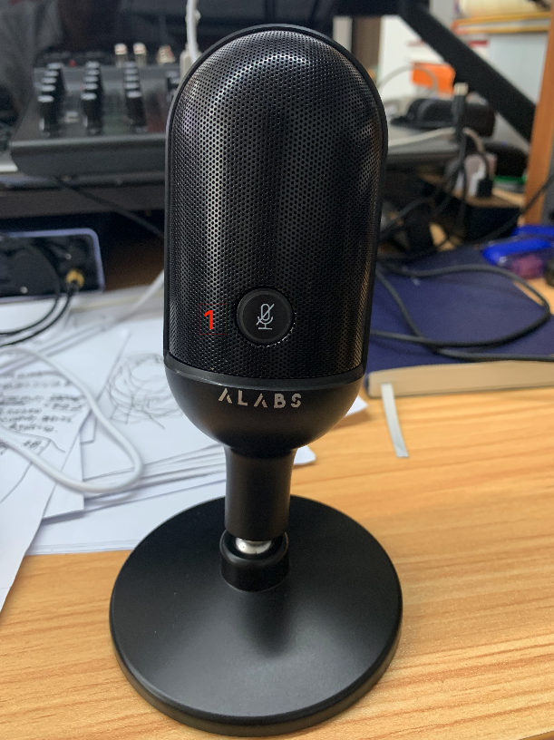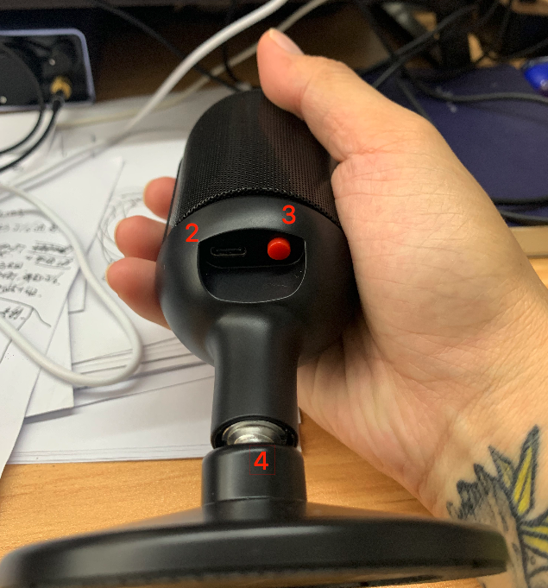

(Transmitter)

1. **Mute touch key:** Press once to mute the Iron Mini, the LED indicator will show RED while it is muted. Press again to recover, the LED indicator will show BLUE while it is working. When the Iron Mini-WL is low battery, the LED will flash quickly to indicate.
2. **USB-C jack:** USB Type-C jack for battery charging. While it is charging, the LED indicator will flash “BLUE” slowly and will stop flashing while the battery is full.
3. **Power button:** Hold 1s to turn on/off the transmitter.
4. **Desk stand:** It’s a detachable stand. Take off the stand, it can be mounted on a boom arm or mic stand. There is a 5/8 to 3/8 adapter inside for different size boom arm and mic stand.

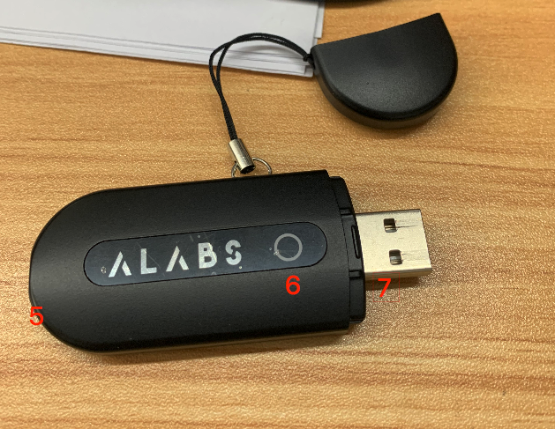

(Receiver)

1. **Headphone Output jack:** 1/8" stereo headphone output jack for output monitoring, which allows you to monitor the microphone input and audio playback in realtime.
2. **Receiver LED:** LED indicator for indicating the paring status. Plug the receiver to your computer / mobile phone and turn on the Iron Mini-WL, the LED indicator will show BLUE while the paring is successful。

***Note: Actual range depends on RF signal absorption, reflection and interference.***

1. **USB-A:** USB-A jack for USB audio connection. You can plug it to your PC, Mac, iOS (needs extra adapter) or Andriod device. System requirements: Windows 8 or higher, Mac OS 10.7 or higher, Android 9 or higher, iOS 10 or higher.

**Setup**

**Mac OS**

1. Plug the **Receiver** into your computer and turn on the power of **Iron Mini-WL**. If paring succeed, the LED of Receiver will show **BLUE**.

***Notes: If the LED of Receiver did not light up, please replug the Receiver to your computer and reboot the Iron Mini-WL (Turn off and turn on).***

1. The computer will automatically recognize the USB device.
2. Open your **System Preferences.**

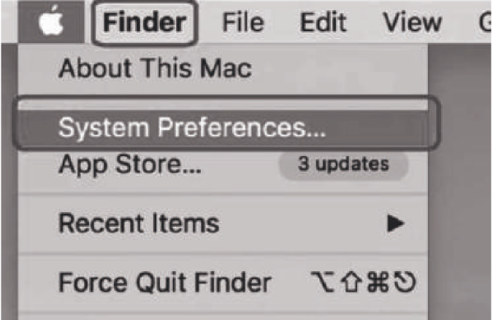

1. Click **sound** to display the Sound preference.

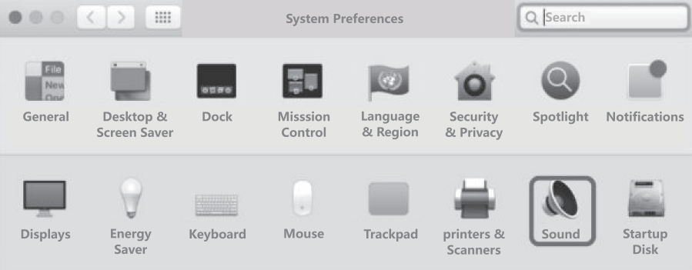

1. Click the **Input** and **Output**, select the **IRON MINI-WL AUDIO DEVICE** as the device for audio input and output.

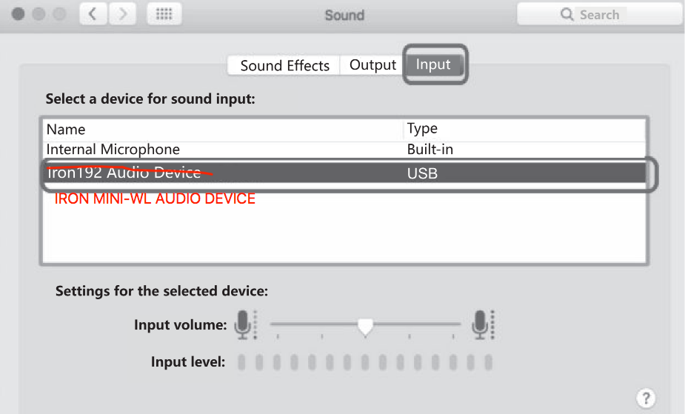

**Windows**

1. Plug the **Receiver** into your computer and turn on the power of **Iron Mini-WL**. If paring succeed, the LED of Receiver will show **BLUE**.

***Notes: If the LED of Receiver did not light up, please replug the Receiver to your computer and reboot the Iron Mini-WL (Turn off and turn on).***

2. The computer will automatically recognize the USB device.

3. Right-click on the **sound icon** on the system tray and select **Sounds**.

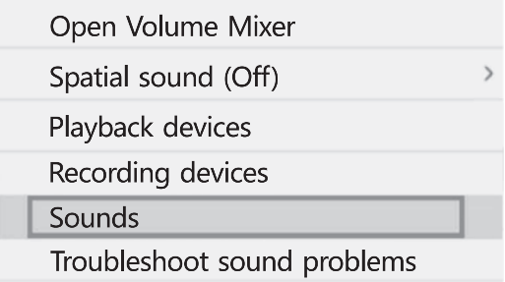

4. Click the Recording tab and select the **IRON MINI-WL AUDIO DEVICE** and click on the Set Default button.

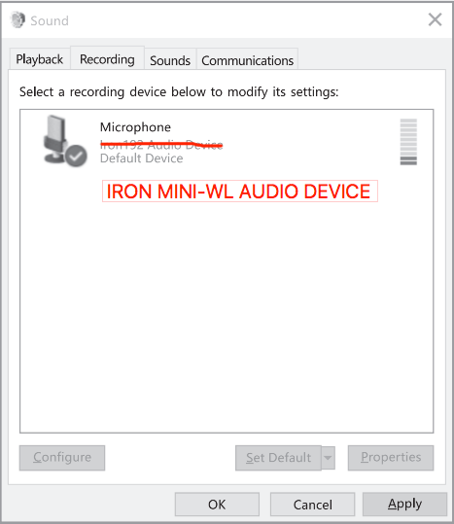

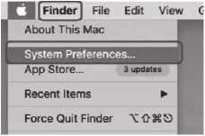**Charging**

Turn on the power of the IRON MINI-WL (Transmitter), the LED indicator will show the battery’s status. If it is low battery, please plug the USB-A to USB-C cable (provided) from USB jack of the IRON MINI-WL to USB charge.

|  |  |
| --- | --- |
| **Battery** | **LED** |
| Normal | BLUE, Always On. |
| Normal, Muted | RED, Always On. |
| Low Battery | BLUE, Flash Quickly. |
| Low Battery, Muted. | RED, Flash Quickly. |
| Charging | BLUE, Flash Slowly. |
| Full | BLUE, Always On. |
| Dead | Flash Quickly and Turn Off |

**Specification**

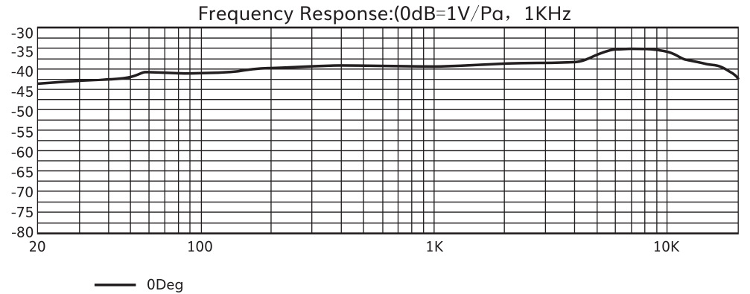

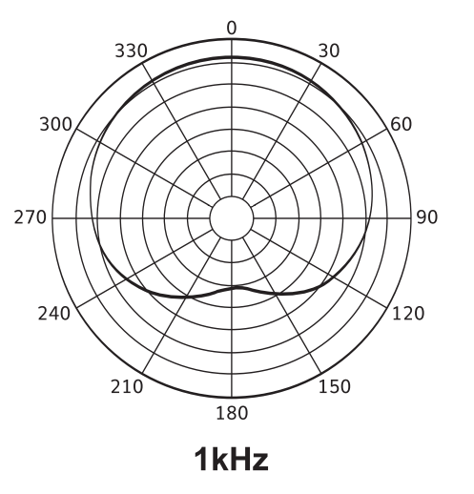

|  |  |
| --- | --- |
| **Acoustic Principle:** | Pressure Gradient |
| **Diaphragm:** | 14mm |
| **Mic Type:** | Condenser |
| **MIC Preamp:** | 36dB |
| **Polar Pattern:** | Cardioid |
| **Input Sample Rate:** | 192kHz |
| **Bit Rate:** | 24Bit |
| **Frequency Response:** | 20Hz-20kHz |
| **Sensitivity:** | -40dB±3dB (0dB=1V/Pa, at 1kHz) |
| **Output Impedance:** | 2.2kQ |
| **Max. SPL:** | 110dB |
| **THD+N:** | <1% |
| **S/N Ratio:** | 94dB |
| **USB Cable Length:** | 2m |
| **PowerOptions:** | USB |
| **Output:** | USB,1/8' stereo headphone output |

|  |  |
| --- | --- |
| **Specification** | |
| **Wireless** | UHF |
| **Working range** | 100 ft (33.3 m) |
| **Acoustic principle** | Pressure Gradient |
| **Diaphragm** | 14mm |
| **Mic type** | Condenser |
| **Polar pattern** | Cardioid |
| **Sample rate** | Min. 44.1kHz / Max. 48kHz |
| **Bit rate** | ??? |
| **Frequency response** | 20Hz - 20kHz |
| **Sensitivity** | ??? |
| **Max. SPL** | ??? |
| **Battery** | 900mAh |
| **Battery Life** | About 8 hours |
| **Charging power requirements** | 5V,500mA |
| **Weight** | ??? |
| **Dimensions** | ??? |
| **Accessories** | 2M USB A to USB C Cable X1. USB A to USB C Adapter. Owner’s manual. |

***\*Notes：Any specification’s update will not be amended in this manual.***

**Troubleshooting**

|  |  |
| --- | --- |
| **No sound or faint sound** | 1. Check the Receiver is connected to computer / mobile phone.  2. Check the Transmitter is turned on.  3. Check the pairing is succeed or not.  4. Check the connection of the Headphone output. |
| **Audio artifacts or dropouts** | 1. System must be set up within recommended range and Receiver kept away from metallic surfaces.  2. Transmitter must be used in line of sight from Receiver for optimal sound.  3. Make sure there is enough power of Transmitter. |
| **Distortion** | 1. Step away from the Iron Mini-WL。 2. Adjust the volume output from your computer / mobile phone。 3. Make sure there is enough power of Transmitter. 4. Transmitter must be used in line of sight from Receiver for optimal sound. |